CO1 AT3
T.RAM PRANEETH REDDY
192512056
Q. Implement a inter VLAN structure that has two VLANS. VLAN 1 IS MESH topology and VLAN 2 is ring topology
ANS:
DIAGRAM
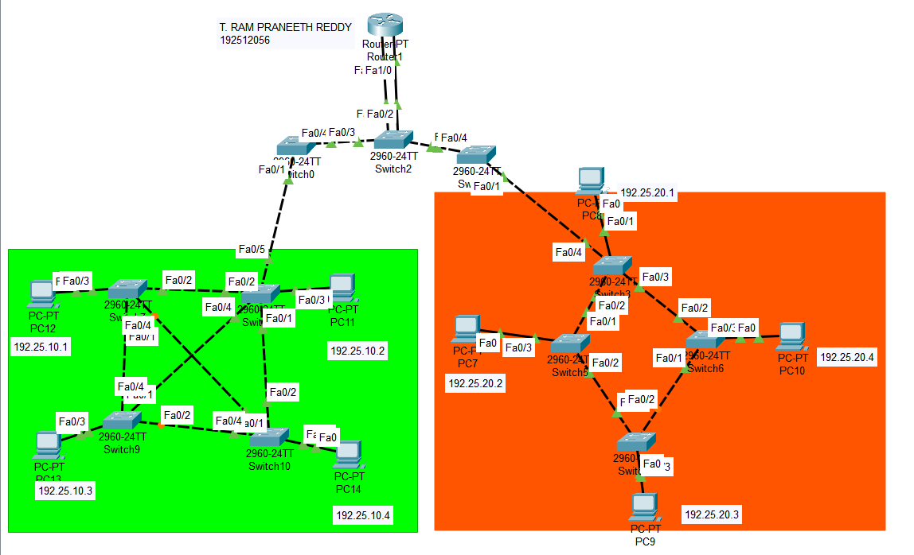
OUTPOUTS:
